Health and Wellness

https://www.leanondee.com
Table of Contents

What You Need to Know 3
Some Facts: 3
What Needs to Be Done: 3
Living Your Best Life at Every Age: 3
Nutrition for Seniors 4
Changing Needs as We Age: 4
Balanced Food Groups: 5
Food Guide Pyramid for Older Adults 6
Exercise for Seniors 7
Types of Exercise Should Include: 7
Consider Different Types of Exercise: 8
Social Connection Between 9
How Lean on Dee Can Help 10

What You Need to Know

Some Facts:
The life expectancy of human beings in the United States is getting longer than ever due to advances in medicine and a better understanding of the aging process.
Statistics from the US Census project that by the year 2050, this segment of the population will increase to almost 87 million, up from over 36 million in 2004.

What Needs to Be Done:
As we prepare for this increase, it’s more important than ever that we focus on ways to support our seniors. It requires more than doctor’s visits and medication, although those are an essential part of senior life.
Maintaining all aspects of health and wellness becomes a priority, and we’re here to help you do that, whether you’re a senior or a primary caregiver.

Living Your Best Life at Every Age:
Managing health and wellness is best done through the development of an individual health routine that supports body, mind, and spirit.
In this booklet, we will focus on these three areas to consider when building your health routine:
Nutrition Exercise Social Connections

Nutrition for Seniors

Needs Change as We Age:
The needs of the body change as we age, and those requirements must be met to continue optimum health.
- Sense of taste and smell diminish, leaving the individual to put more salt or sugar on their food, which can lead to health problems.
- As we age, we often develop digestive issues that require a change in diet. Often, nutrients conflict with prescribed medications and dietary changes are necessary to compensate.
- It is common for saliva production to decrease in seniors, along with the ability to produce the enzymes that help to break down and digest food.
- The older we get, the more difficult it is to maintain a healthy weight. Overeating can lead to a host of health risks, such as heart disease, cancer, high blood pressure, and diabetes. Undereating has risks involved too, such as memory loss and weakened immune response.
It is possible to eat well without an expensive, complicated plan. Sticking to whole foods, such as fresh produce, and avoiding pre-packaged, processed foods will help keep the body healthy.
Resources for help with nutrition include: Meals on Wheels, Grocery or Meal Delivery, Caregiver Services

Balanced Food Groups:
The USDA recommends that seniors enjoy samplings from all the food groups, as outlined below:
Protein: Find protein in green leafy vegetables, meat, fish, poultry, eggs, cheese, nuts, and seeds. Protein helps build and maintain your muscles, skin, and nails.
Carbohydrates: Carbohydrates, or “carbs” as they are commonly known, help maintain energy and internal organ function. Find carbs in low fat dairy products, whole grains, vegetables, and fruit.
Fiber: Fiber can be found in beans, fruits, vegetables, and products that contain whole grain. It will help with gut health, and can help with other health issues, such as high blood sugar, and high blood pressure.
Healthy Fats: Eating healthy fats will help to protect your cells and will keep your energy levels high. Foods that are fortified with omega-3 fatty acids can help you meet your healthy fat requirements. Healthy fats are also found in nuts, oils, and some fish.
Fluids: Drinking lots of water and staying hydrated helps the food you eat to work its magic for your body. You also need to stay hydrated to maintain a healthy body temperature. If you don’t like water, supplement that with green tea or juices from fruits and vegetables. Just be sure that you’re not taking in too much sugar through juices.

Food Guide Pyramid for Older Adults

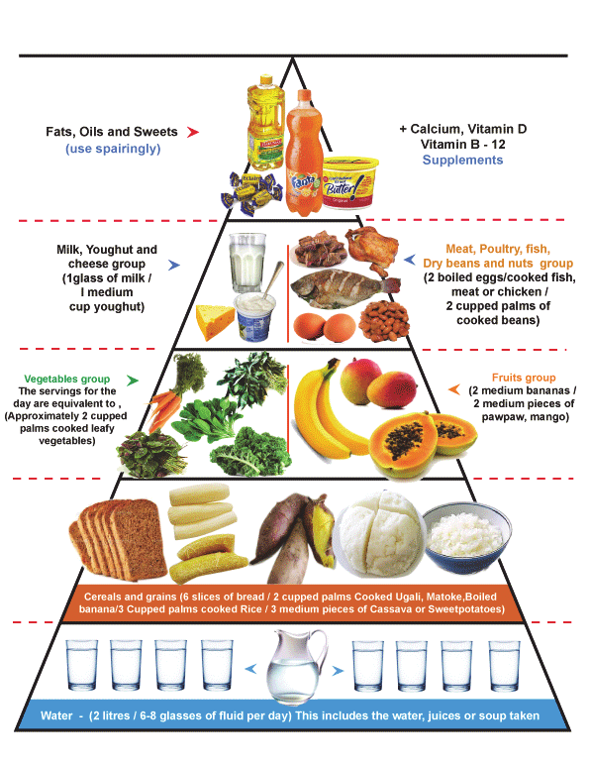

Exercise for Seniors
Exercise helps seniors to live better, more active lives. Participating in physical exercise and activity helps prevent falls, and decreases the possibility of depression in seniors, and can help with chronic conditions, such as diabetes and heart disease.
It’s recommended that seniors should exercise at least five days a week, and for at least thirty minutes to gain maximum results. Keeping it fun, and within a person’s range of motion, can help them to stay fit, and may prolong their life and independence.

Types of Exercise Should Include:
Strength Training: Using exercise bands or weights can help to improve endurance and increase muscle strength. Care should be taken to use light weights and bands to prevent injury.
Flexibility: Light stretching can help recover from injuries and help improve your balance and mobility. Keeping your body limber helps with everyday movement.
Balance: Doing balance exercises can reduce your chances of falling. Find balancing exercises that you like such as yoga and tai-chi. You might want to enroll in physical therapy services which can assist you in working on your balance.
Endurance: Increasing your breathing and heart rate can help your body to become conditioned and in better shape. Start slowly and build on your progress gradually to prevent injury.

Consider Different Types of Exercise:
Exercise doesn’t have to be boring! In fact, the more fun you have, the more likely you are to do it on a regular basis.
Have you tried any of these?
Look for a mall walkers’ group if there is a mall nearby. This allows you to walk rain or shine.
When was the last time you had a nice walk, or a nature hike? If there’s a nature center or park nearby, check to see if there are organized hikes, so you can walk with others.
Fancy a swim? Check with local pools and see if they have a senior’s swimming class, or water aerobics.
Dancing is still in fashion… in many different forms. Learn line dancing, ballroom dancing, or many other types of dance.
Yoga and Tai Chi are great for your balance and can create a meditative mind as well. Good for body, mind, and spirit.
If you’re new at exercise, or you’ve been out of the game for a while, contact your local senior center for Seated Chair Exercise Classes.

Social Connection Between Seniors
Feeling isolated and depressed can actually affect a person’s physical health. It’s not all in the mind.
Social connection is so important in a senior’s life. There are so many ways to connect these days:
Online: People of all ages use the internet these days to connect with one another and form groups with common interests.
Church: Most denominational churches have senior outreach groups. Even if you don’t believe in organized religion, you can find an independent spiritual group to help you explore your spirituality.
Political: Seniors often find more time, and interest in being involved in the political process, and can be great at advocating for senior rights.
Crafts and Creativity: Taking a few craft classes, or just getting together to do some knitting or quilting can help to keep your creative mind engaged.
Volunteering: There are so many organizations that could use volunteer help. Find one that you’re interested in and gain the deep satisfaction that comes from helping out.
Lifetime Learning: Today’s colleges have courses geared towards senior interests. Check them out to see if you want to take a course or two.

How Lean on Dee Can Help?

Companion Services
We create customized care plans and manage them closely. Our experienced team and friendly companions ensure consistent, high-quality care. With flexible schedules, our caregivers are available whenever and wherever needed, enabling clients to maintain their regular activities.

​Nurse Assisted Doctor Visits
Sometimes it seems like doctors are speaking another language. Our Nurse will assist with preparation for doctor’s appointment, communication with the doctor on behalf of the family and the client, comprehensive post-visit summary, and follow-up per physician’s orders.​

Home Safety Assessment
We will assess the living environment and make recommendations for hardware and fixtures that may need to be installed or repaired to help to support your loved one in the home and making referrals to our list of trusted partners for services that can assist in fixing or installing them. Our goal is to reduce falls and avoidable hospitalizations.
​

