Living Your Best Life
Medicare

www.leanondee.com
TABLE OF CONTENTS

Page 1 …. What You Need to Know
Page 2 …. Common Misconceptions
Page 3 …. The Different Parts of Medicare

Page 5 …. How and When to Enroll
Page 6 …. Medicare Appeals
Page 7 …. Fraud & Abuse Prevention
Page 8… How We Can Help

What You Need to Know
Medicare is a National Program to help Seniors over the age of 65. For most people, it is confusing. When it is time for seniors to enroll for coverage, it’s best to have a professional guide them… someone who knows the ropes and can explain the program and give them advice when needed.
The Role of the Social Security Administration
The Medicare program is administered by the Social Security Administration. They check enrollment and eligibility.
Financial Qualification
Unlike Medicaid, Medicare has no financial qualification threshold, and is a program available to eligible applicants, regardless of their income level.
Medicare has Four Distinct Parts
In this booklet, we have a section dedicated to the four parts of Medicare, and the difference between them. Once you understand them, it’s easier to see how they work together like pieces of a puzzle, to provide you health coverage in all areas.
Medicare is Funded from a Variety of Sources
Working Americans contribute to Medicare through their paychecks. They receive general revenue, and participants pay premium for coverage.
Common Misconceptions
Medicare is Free and Covers Everything
Medicare is not free. Recipients pay premiums, deductibles, and co-pays just like they would with standard health insurance. The benefits are limited, and they will only pay for a certain number of days of inpatient hospital, or a skilled nursing facility
Medicare Covers Long Term Care
Although Medicare does cover short term stays (100days) in a skilled nursing facility for nursing or rehabilitation, it does not cover long term care over those limits.
People Can Enroll in Medicare Whenever They Want
This is not true. In fact, they are strict about signing within certain time parameters, which means a person should start doing their research into Medicare well before their 65th birthday.
Part D Will Cover All Prescriptions
There are certain prescriptions that will not be covered by Medicare. If you require a prescription for erectile dysfunction, hair loss, weight loss, or any over the counter medicine or vitamin supplements, you must pay for them out of pocket. They are not covered under Medicare Part D
The Different Parts of Medicare
Medicare Part A
Part A is Hospital Coverage. To enroll in this Part of Medicare without penalty you must apply within seven months of your 65th birthday. It covers inpatient hospital stays, skilled nursing facilities, home health, and hospice care.
Medicare Part B
Part B covers physicians, outpatient hospital, ambulance, durable medical equipment and prosthetics.
Together Part A and Part B Make up Original Medicare.
Medicare Part C
Part C is also called Medicare Advantage. It’s an alternate option for your health care coverage. Instead of being a government program, it’s run by private insurance companies. They receive a set amount from the government for each beneficiary. They agree to cover everything covered by Original Medicare (Part A + Part B)
Medicare Part D
Part D covers your prescription drug plan when you order prescribed drugs through a local pharmacy or through a mail order service.
Medicare Supplement or Medigap Insurance
Original Medicare Insurance can contain gaps in coverage that are not paid by Medicare.
Many beneficiaries opt to purchase Medicare Supplement, or Medigap Insurance. The best way to describe this coverage is to say that it covers whatever your original Medicare does not. This serves as a safety net to keep you from getting stuck with large outlays for medical costs.

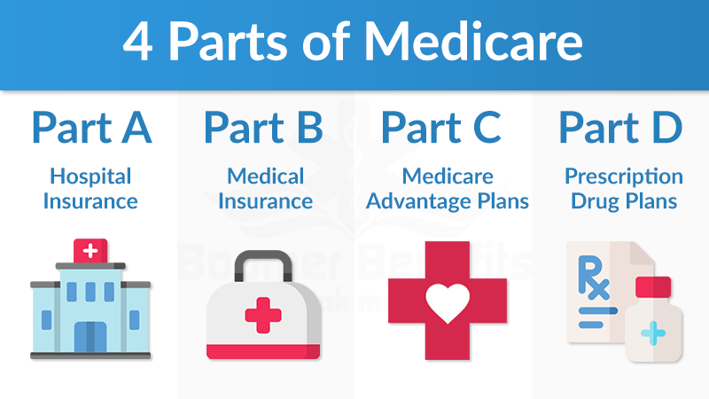

How and When to Enroll in Medicare
Initial Enrollment Period
When you enroll in Medicare Part A, for the first time, you need to sign up in a seventh month window around your 65th birthday. The seven months include your birthday month, and the three months before, and the three months after your birthday month. Special exceptions are made for those that continue working after age 65, or have a supporting spouse that carries them on company insurance after 65.
If you are receiving Social Security benefits when you turn 65, you will automatically be enrolled in Medicare.
Part A is available at no charge, provided you have enough social security payroll time on the books. If don’t, you can purchase Part A , as long as you meet the age and residency requirements.
Where to Go to Sign Up
When you are ready to sign up for Medicare, go to your local office of the Social Security Administration. They will help you to enroll and explain to you the time frames for signing up for additional coverage other than Part A.

Medicare Appeals

It is not uncommon for claims to be denied for home health care, ambulance fees, and Durable Medical Equipment. It’s important to file an appeal if you think your claim has been wrongly denied.
Making an Appeal When Your Claim is Denied
Anytime a charge that should be covered is denied through Medicare, you have the right to appeal. Denials can happen for a variety of reasons. People make errors, don’t have the information they need to process the claim, or have made a subjective decision based on their understanding of the coverage.
Each Part of Medicare has its own appeal process and timelines,
Wait, There’s Good News!
The good news is that beneficiaries cannot be billed by the provider if the beneficiary expected Medicare to pay it. If the provider suspects that Medicare will not pay it, they will have the beneficiary sign before receiving treatment. In these cases, the beneficiary can expect to receive a bill for unpaid claims.

Fraud and Abuse Prevention

It is a crime to defraud the Medicare program, but that does not seem to matter to some bad players in the system.
There are often elaborate, organized schemes to defraud the Medicare program by using stolen Medicare numbers and filing bogus claims for reimbursement and payment for services that were never provided.
You can help by keeping your Medicare Card and number safe, and by checking behind your provider to make sure that you received all the services you were billed for.
The Federal task force assigned to this problem has returned more than $23 Billion to Medicare Trust Funds since its inception in 1997.
Resources:
www.medicare.gov Medicare Web Site
www.ssa.gov Social Security Web Site
www.leanondee.com Senior Care Advocates

How Lean on Dee Can Help Seniors?
Senior Wellness Check-Ins
We offer direct communication and support while assuring that the emotional, physical, and spiritual well-being of your loved ones are addressed. We do this by providing three Wellness Check-In visits per month where we utilize a monthly assessment tool to gauge any changes that may occur.
Home Safety Assessment
We will assess the living environment, and make recommendations for hardware and fixtures that may need to be installed or repaired to help to support your loved one in the home and making referrals to our list of trusted partners for services that can assist in fixing or installing them. Our goal is to reduce falls and avoidable hospitalizations
​Housing Placement

There is a range of reasons why your loved one may need assistance in relocating to a senior living community or skilled nursing facility. If the occasion ever arises, we will be there to help you find the best option for your price range and level of care.
​

